**Academic Year 2024-25**

**FY MCA- SEM II**

**IT21: Cyber Security**

**Assessment III – Cyber Audit**

**Date: 24/04/2025 Time: 60 Mins Marks: 50 Marks**

**Instruction:**

1. **Total 6 questions are there. All questions are compulsory.**
2. **Kindly execute Q.1, Q.2 and Q.3 and copy screenshots below your question.**
3. **Q.4, Q.5 & Q.6 are descriptive. You need to type in your answer below the question.**
4. **Rename this file as “roll_no_student name” and upload on mastersoft.**

**Roll No:**

**Name:**

**Q.1 [02 Marks]**

|  |  |  |  |  |
| --- | --- | --- | --- | --- |
| **Security Control Type** | **Password/Policy/Permissions** | **Location & PC No.** | **Yes/ No** | **NA** |
| Firmware password | BIOS password | **PC05** |  |  |

**Answer: (Paste screenshots for Q.1 here)**

**Q.2 [18 Marks]**

|  |  |  |  |  |
| --- | --- | --- | --- | --- |
| **Security Control Type** | **Password/Policy/Permissions** | **Location & PC No.** | **Yes/ No** | **NA** |
| Operating System Access Control | OS genuine/ Activated | **PC05** | **Yes** |  |
| Strong User passwords | **No** |  |
| Screen saver lock | **Yes** |  |
| Password policy | **No** |  |
| Account lockout policy | **No** | **NA** |
| Security audit policy | **No** |  |
| NTFS permissions | **Yes** |  |
| Share permissions | **Yes** |  |
| Windows Updates installed and updated | **Yes** |  |

**Answer: (Paste screenshots for Q.2 here)**

OS genuine/ Activated

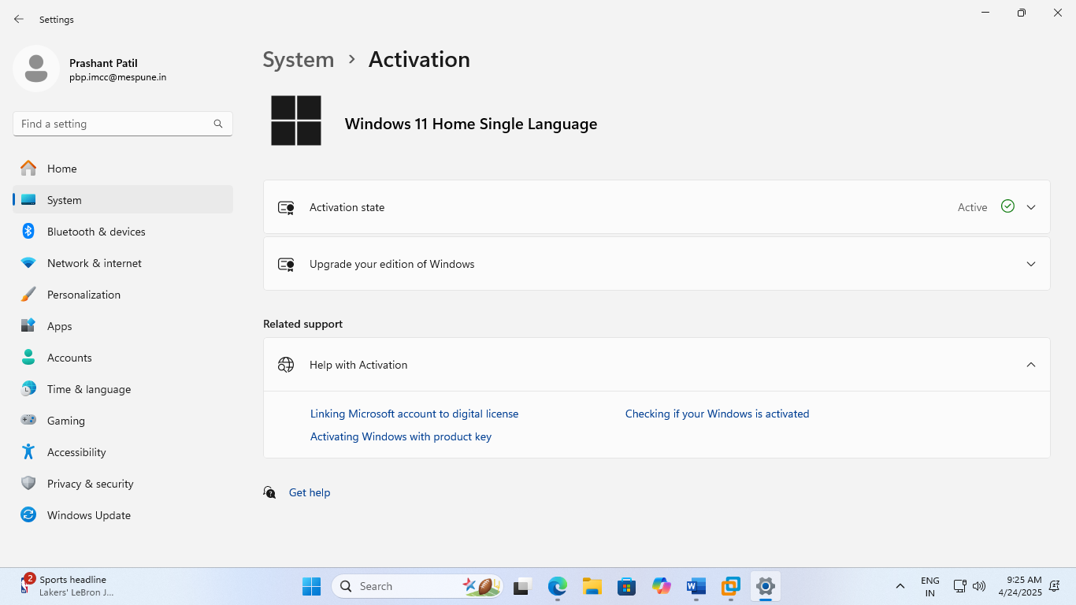

Strong User passwords

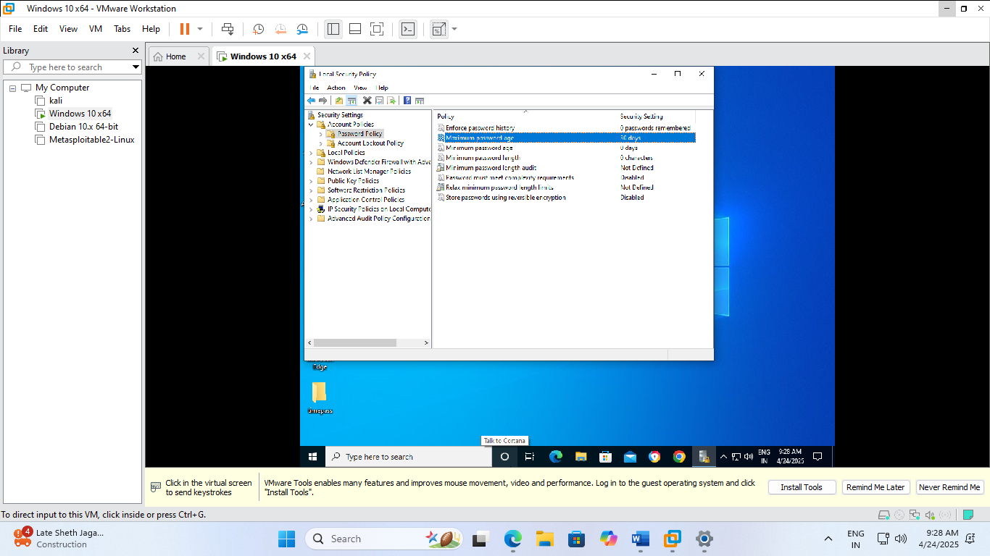

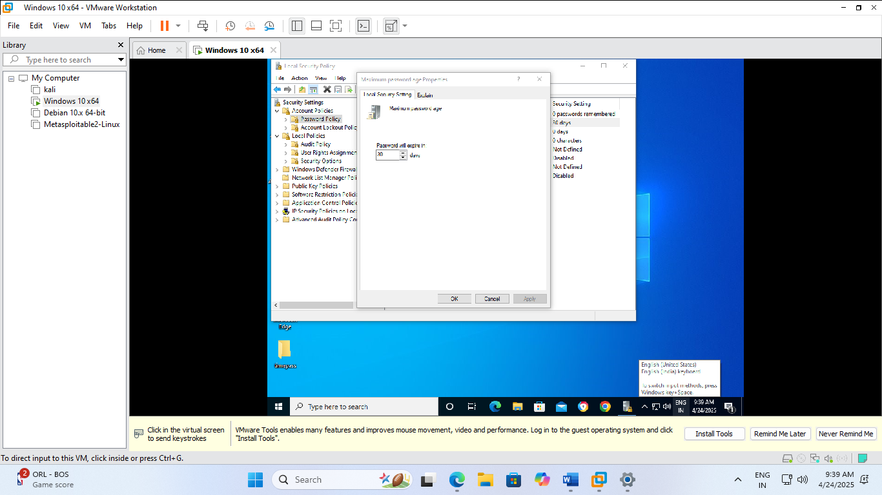

Screen saver lock

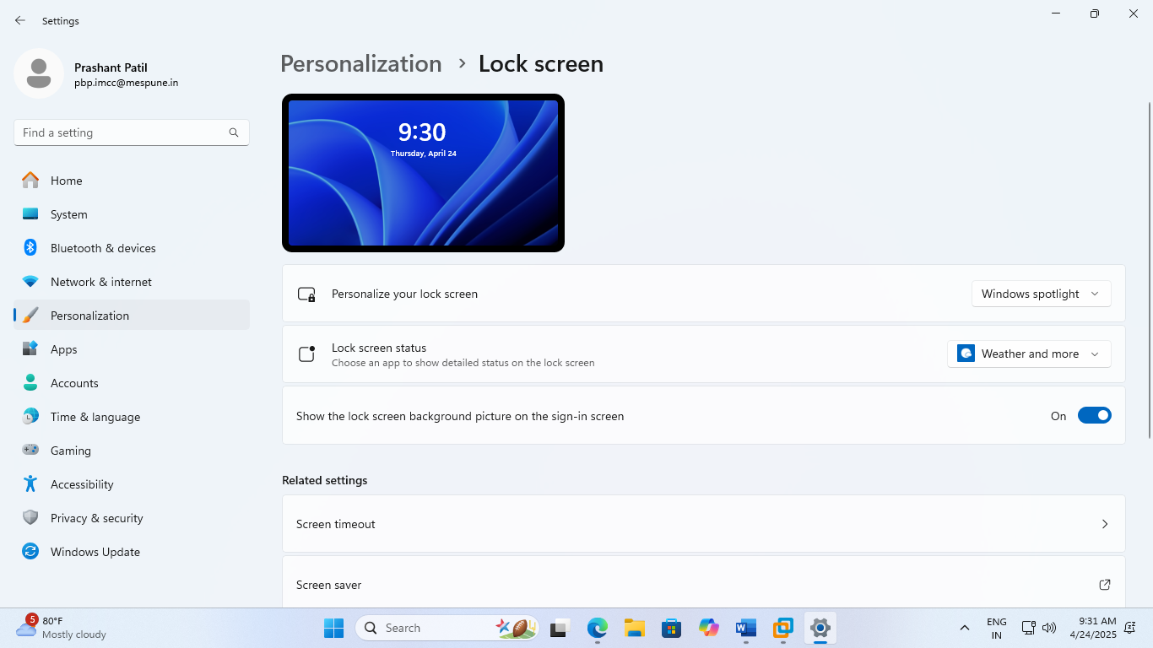

Password policy

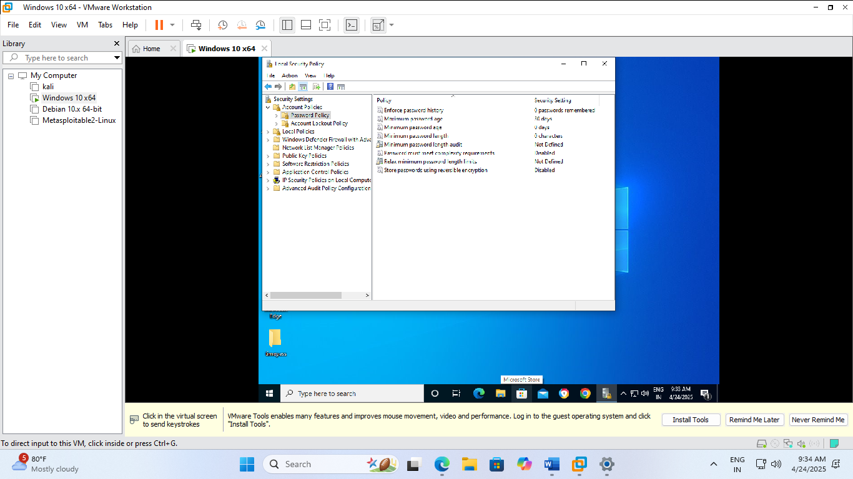

Account lockout policy

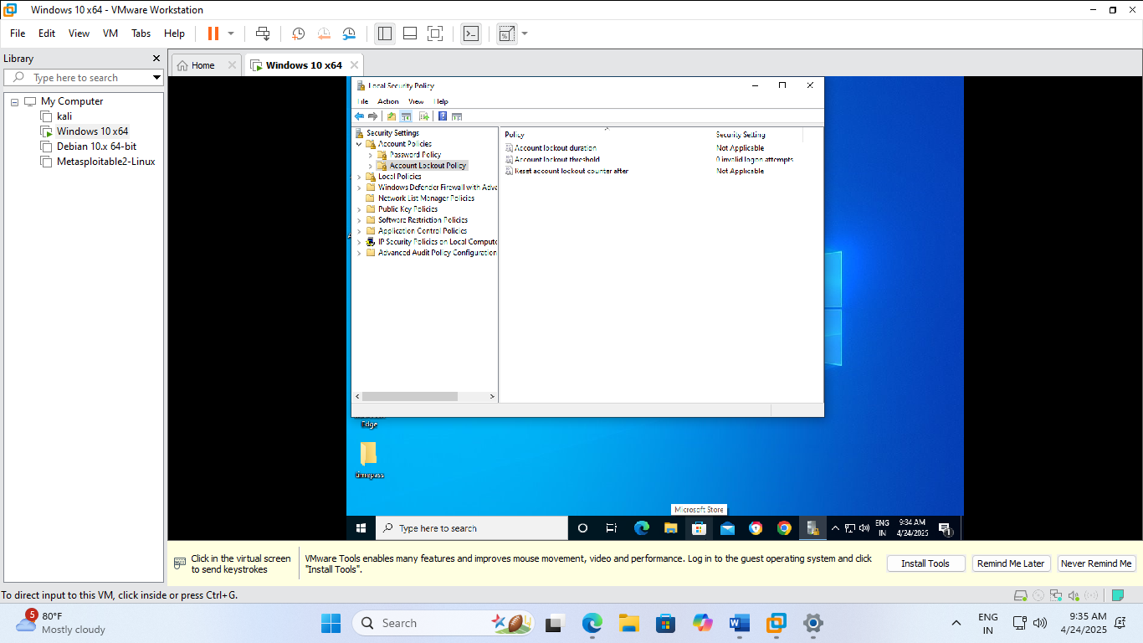

Security audit policy

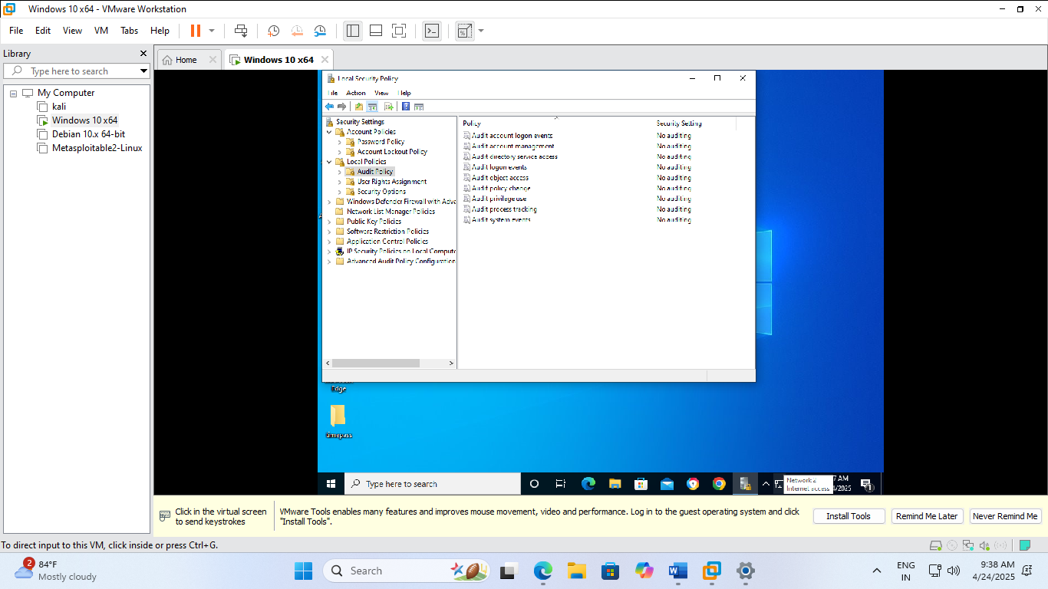

NTFS permissions

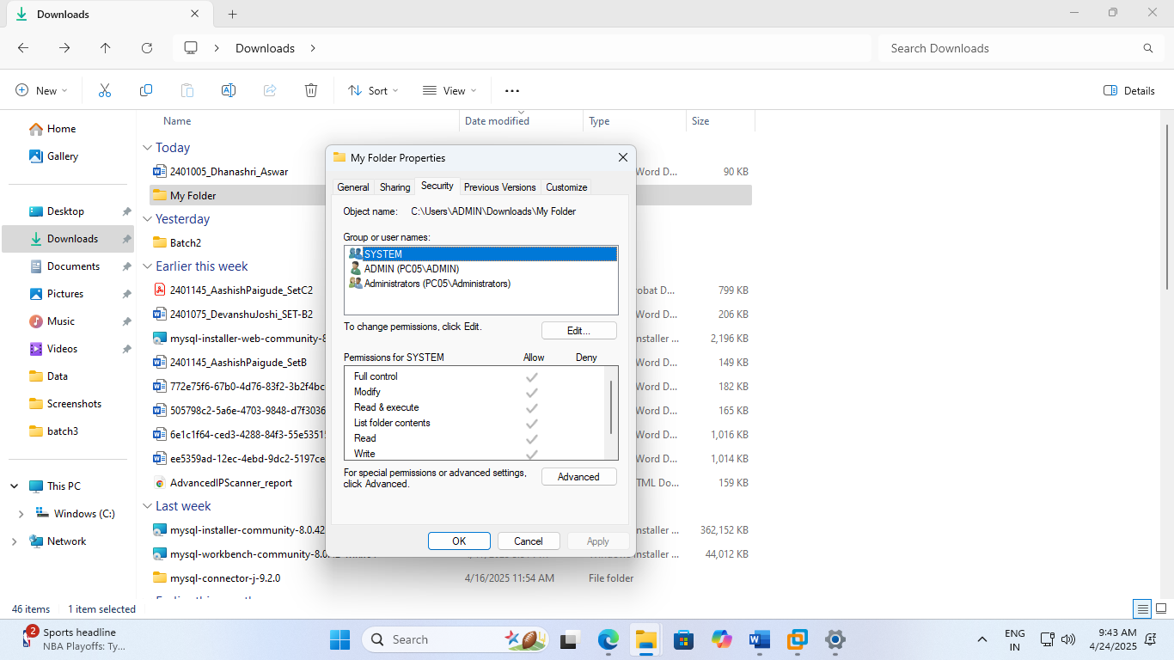

Share permissions

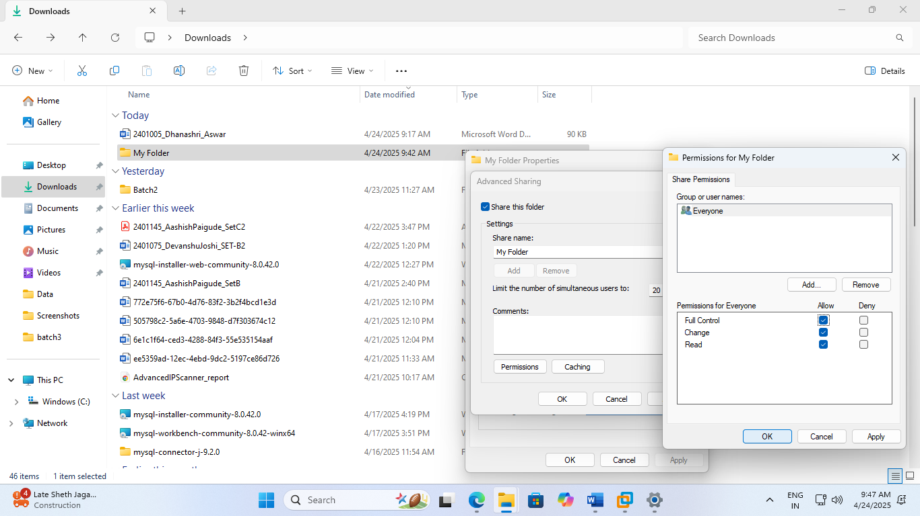

Windows Updates installed and updated

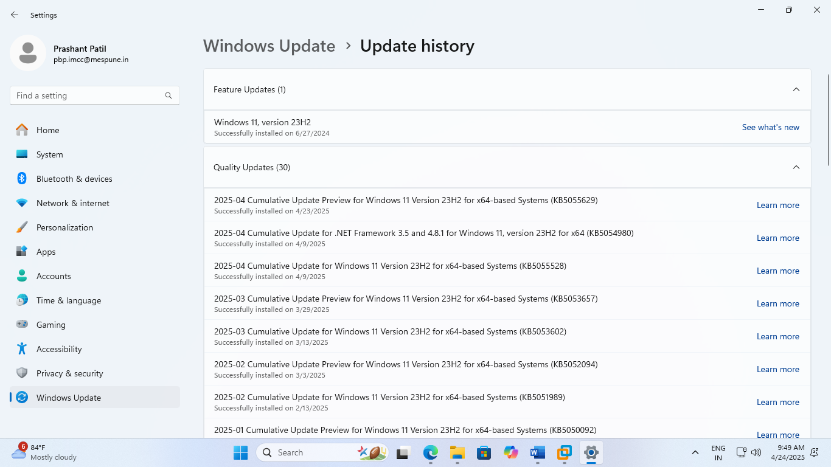

**Q.3 [06 Marks]**

|  |  |  |  |  |
| --- | --- | --- | --- | --- |
| **Security Control Type** | **Password/Policy/Permissions** | **Location & PC No.** | **Yes/ No** | **NA** |
| Network Access Control | Host firewall Enabled | **PC05** | **Yes** |  |
| Antivirus Installed and Updated | **No** |  |
| Web browser security settings | **No** |  |

**Answer: (Paste screenshots for Q.3 here)**

Host firewall Enabled

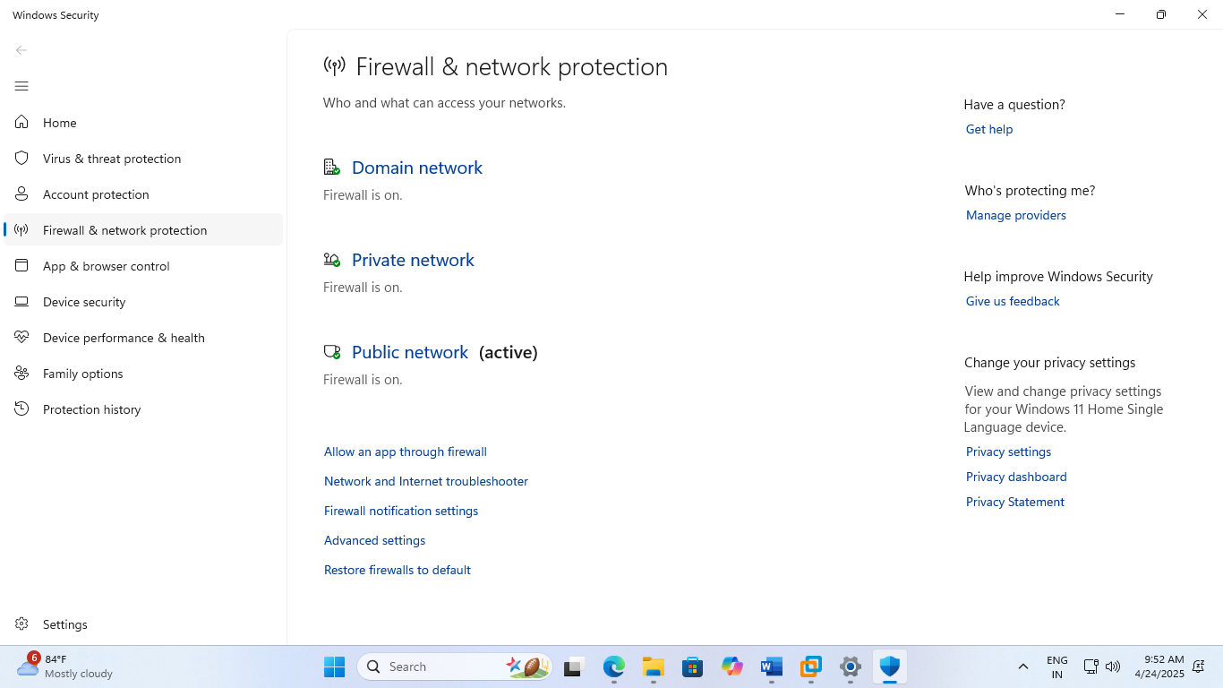

Antivirus Installed and Updated

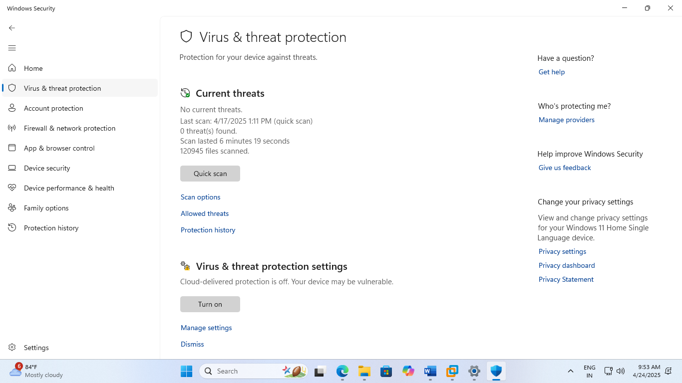

Web browser security settings

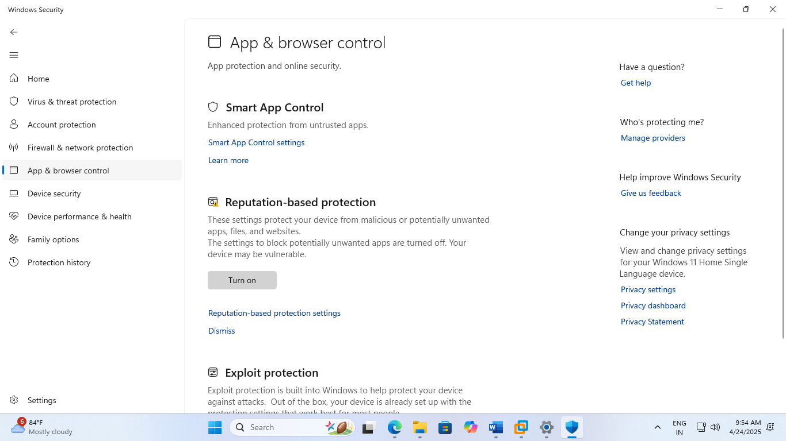

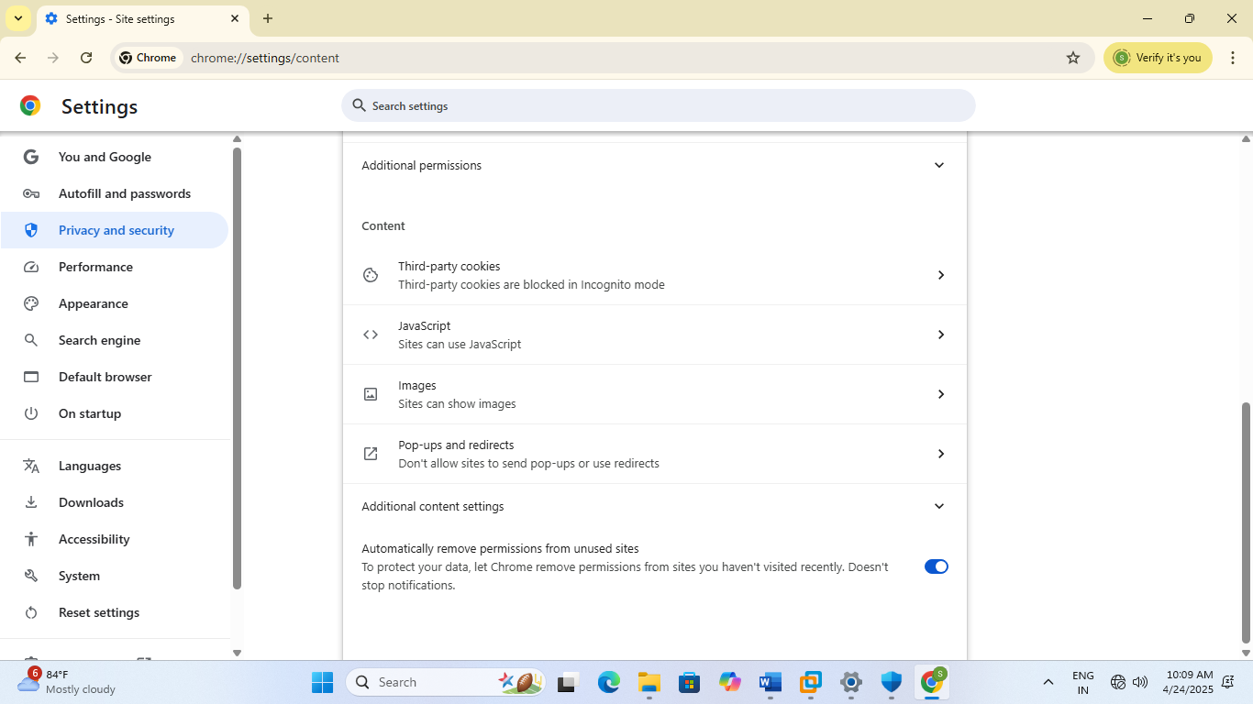

**Q.4 Based on your above findings about audit, explain following: [08 Marks]**

**a) Vulnerability found in your audit**

**b) Scope of security**

**Answer: a) Vulnerability found in your audit** : Based on the above findings about audit, the vulnerability that I found is system may be vulnerable as cloud delivered protection is off.

In App and browser control, Reputation based protection, the settings which protect device from malicious or potentially unwanted apps, files and websites and block potentially unwanted apps this setting is turned off. Strong password policies are not enforced. Auto lockout policies are not set for the system which can be risky. Security audit policies are also not set. So, the system can be vulnerable.

**b) Scope of security :**

* Overall the system should be updated with latest windows version.
* The password should be strong which should be at least 16 digit including at least 1 capital letter, small letter, numbers and special character
* BIOS password should be set for boot process.
* Auto lockout policies, security audit policies should be enforced.

**Q.5 State and explain in detail IT Act 2000 and its amendments. [08 Marks]**

**Answer:**

* The IT Act of 2000 brought many changes in regard with data privacy, protection of data, and personal information.
* It brought amendments in the area of cyber security domain.
* The strict laws were made for the data privacy of organization as well as individuals.
* Cyber security cell is also there to help the victims of cyber attacks.

**Q.6 Difference between internal and external security audit. Explain in detail. [08 Marks]**

**Answer:**

**Internal security audit**

* Internal security audit includes the auditing performed by the organization by themselves without any external person out of the organization.
* They can do the security audit thoroughly without any risk of data breaches
* They check the physical system and machines and perform the auditing.

**External security audit**

* The external security audit is performed by professionals or experts of cyber security.
* They have more experience of cyber security and can do it in a better way.